

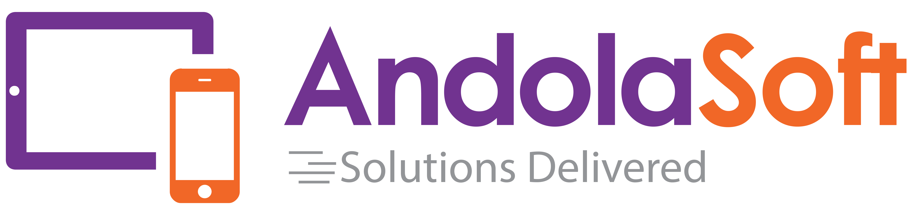

**Proposal and Specification for:**

**Mobile Application Development for CRM-4Beauty**

Presented by

**Andolasoft**

HQ & West Coast  
2059 Camden Ave. #118,

San Jose, CA

95124  
USA

Submitted to:

**Max Rockwell**

Marketing Director, 4Beauty

Presented by:

**Anurag Pattnaik**

Manager- Delivery & Business Development

Andolasoft Inc.

*Date:3rd Aug, 2016*

Hello,

It is with great pleasure that I present to you our proposal. Having recently developed an in-depth understanding of the 4Beauty company vision, I believe Andolasoft would be an ideal partner to design and develop the Native Mobile application. Our team of expert developers and creative talent are a perfect match to meet the technical and aesthetic vision of CRM-4Beauty.

Our proven track record for projects large and small, including numerous startups, gives us the ability to create a product based on prior successes as well as collective insight.

We appreciate your consideration and confidence. Please contact Mr. Anurag Pattnaik at anurag.pattnaik@andolasoft.com with any questions.

Best Regards,

Anurag Pattnaik

Manager- Delivery & Business Development

[www.AndolaSoft.com](http://www.AndolaSoft.com)

**Executive Summary**

This Business Proposal represents a combination of strategic guidance as well as best practices in user experience design and development for the Mobile application.

Based on the idea of CRM-4Beauty, we understand the goal of our initial engagement is the development of a functioning mobile application which will be developed for iOS & Android platform.

**TABLE OF CONTENT**

1 Company Profile 4

2 Case Study – Auditnet mobile application development 5

3 Company Portfolio 6

4 Benefits of Hiring Us 12

5 Why iOS app? 12

6 Project scope 12

7 Deliverables & Releases 13

8 Sample App Screenshots 14

9 Team structure 14

10 Project Timeline& Cost Estimation 15

11 Payment Method and Phases 15

12 Support & maintenance plan for mobile app (Optional) 15

13 Change Request Process 16

14 Terms & Conditions 16

# Company Profile

**Who we are**

We are a dynamic Web & Mobile development company based in San Jose, CA having development centre in India. We design, develop Web, iPhone, iPad, AndroidApps for start-ups & established businesses. We are agile and do help clients by delivering projects in time and within budget. We believe in quality work done by our experienced resources. We have satisfied customers spread across the USA, Canada, Australia, UK, Singapore& Brazil. Andolasoft awarded as best mobile app Development Company by ***Mashable*** in ***June 2014***.

**What we do**

Andolasoft is providing you the opportunity to move out of your cubicle and use the amazing mobile apps and services developed by us. Our innovative and creative developers understand the requirement of our clients and choose a most optimized beneficial solution and then convert that into a product. We're developing apps featuring maps, store locators, online orders & bookings, social sharing, product or service rating and many others. Currently we're developing apps for iPhone, iPad & Android smartphones.

**Why choose us**

The company values stand on the understanding that our success is tied to the success of our clients. We work closely with our customers to ensure that we meet the service levels on the most CTQ parameters of **'flawlessness'**, '**within budget**' and '**on time'** application development along with strong security measures to safeguard customer data and information.

**Our Strategy**

Our strategy is simple. We stick to an agile process flow, which includes seven critical steps: Unearth >> Design >> Develop >> QA >> Launch >> Measure >> Iterate

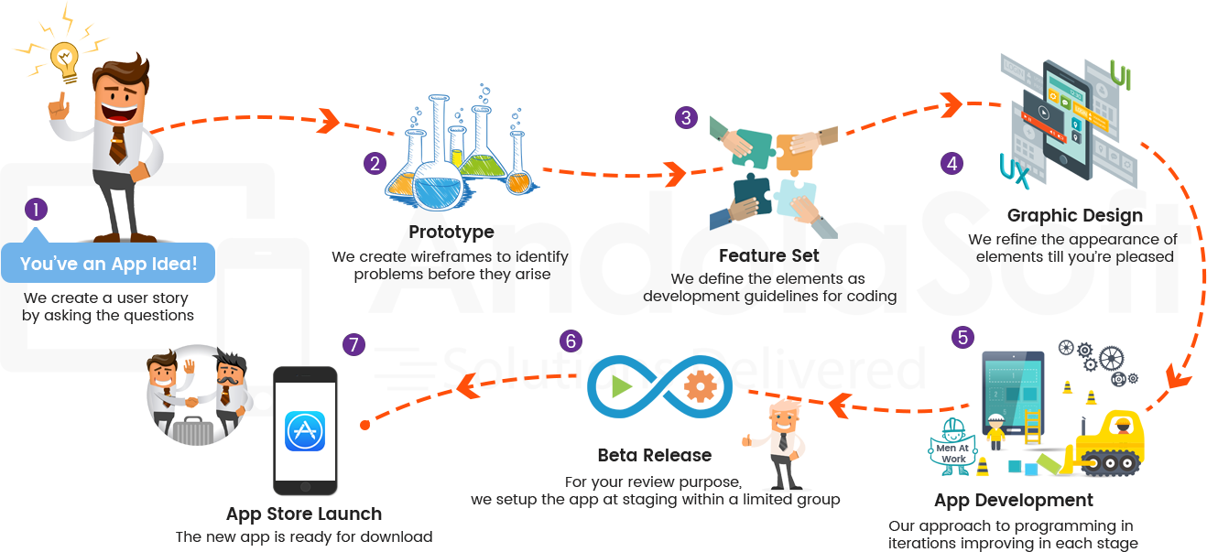

# Case Study – Auditnet mobile application development

**Introduction**

AuditNet serves the global audit community as the primary communications resource with an online digital network where auditors share resources, tools, and experiences including audit work programs and other audit documentation. The AuditNet web application is designed to handle larger user base and online payments for the subscription plans.

**Problem**

Due to the growth of smartphone application usages, there was an opportunity for AuditNet to attract smartphone users looking for audit application. Also the smartphone application would help the existing users to seamlessly access the audit tools/contents inside their smartphone application without need to browsing the website.

**Analysis & Recommended solution**

Andolasoft helped AuditNet to analysing the audit industry and the website for the smartphone application development. Andolasoft proposed a cost effective solution for AuditNet to develop a smartphone application which will run seamlessly on each platforms like iOS and Android.

**Implemented Solution**

Andolasoft developed the mobile app as well as the backend API endpoints which communicates to the AuditNet web platform. The mobile application development completed within 10 weeks of the timeframe. Andolasoft also helped AuditNet to place the smartphone application on the respective market places for iOS and Android . For iOS, Apple’s inApp purchase is implemented and for Android platform we have implemented the PayPal payment system like the web. The mobile app also has the functionality to download the audit templates/tools and access it from the app itself.

**Results**

The smartphone app developed by Andolasoft helped the AuditNet users to use the Audit templates/tools easily. Due to the integrated payment system users are also able to renew/upgrade the subscription plans seamlessly. This flexibility of the mobile app increased the user conversion ratio of AuditNet to 80% growth.

# Company Portfolio

Some of our Recently Developed iPhone/iPad applications

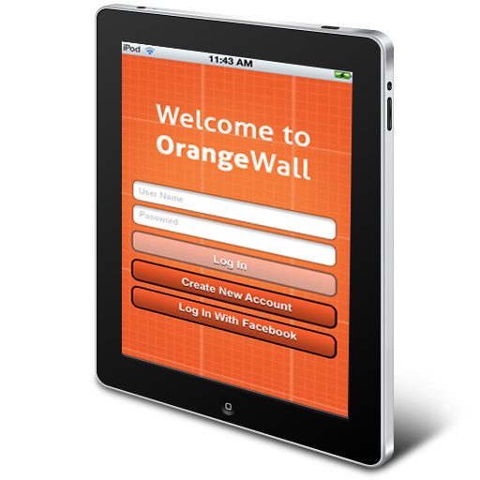

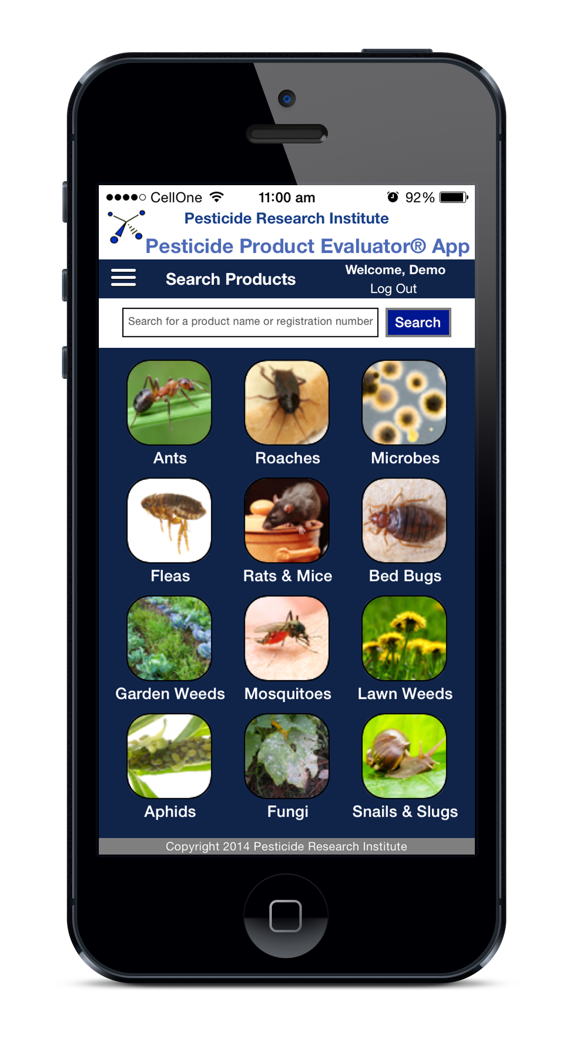

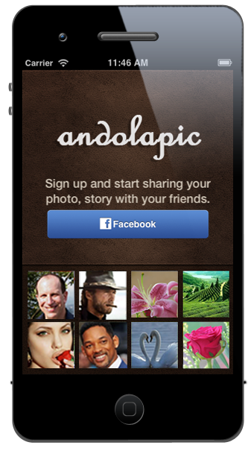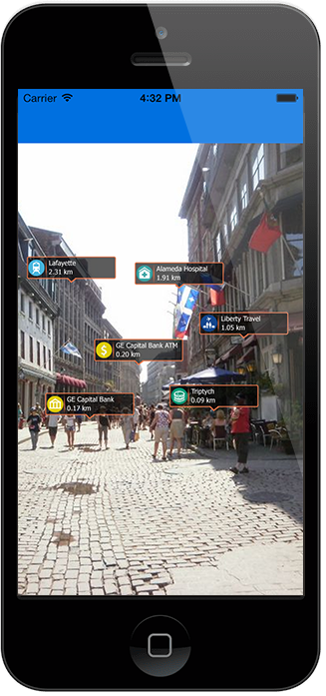

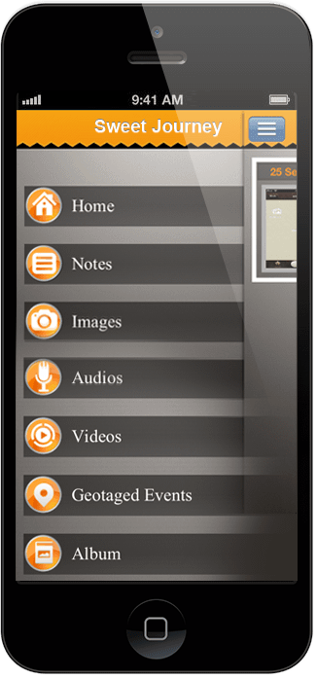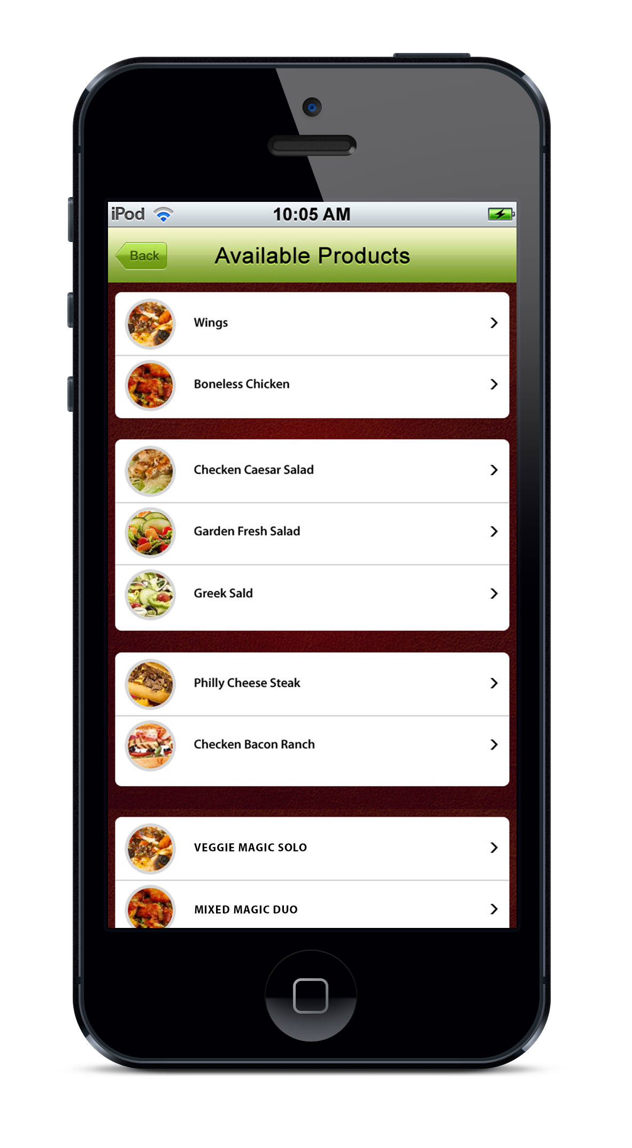

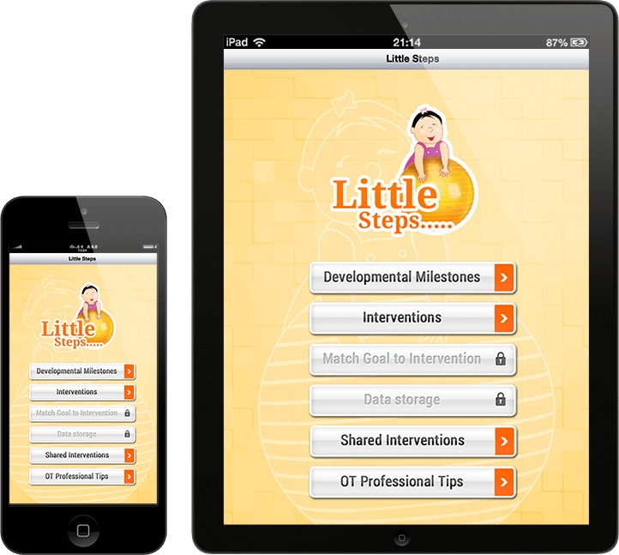

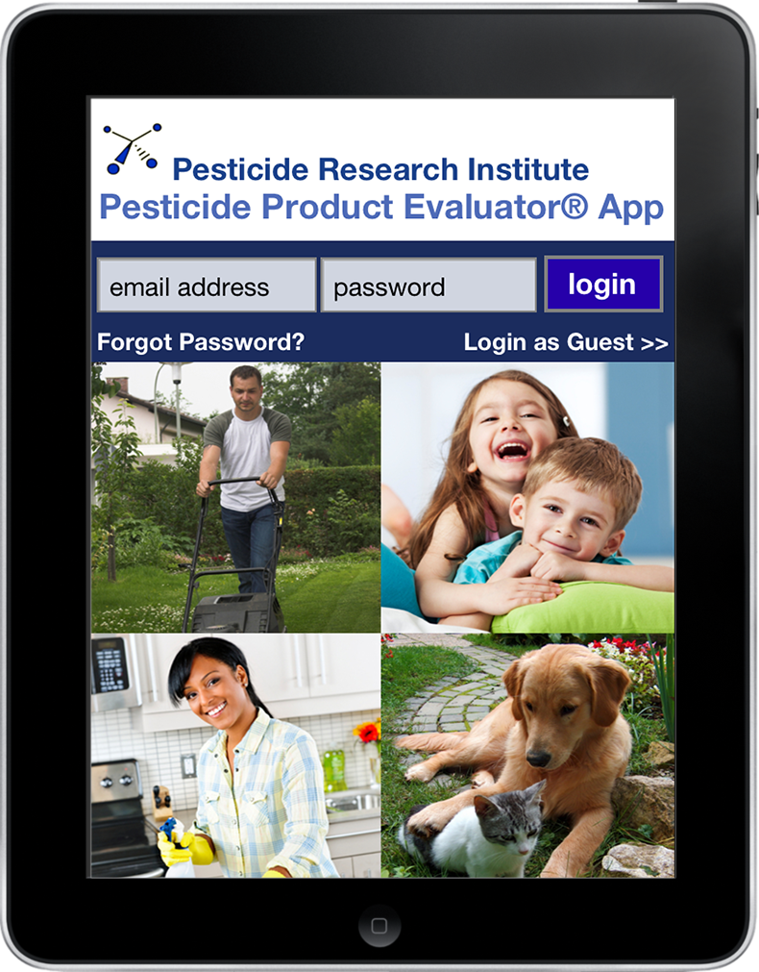

Some of our Recently Developed Android Apps

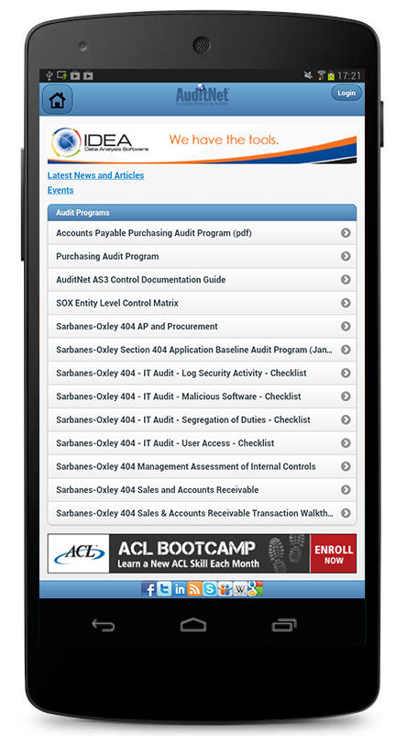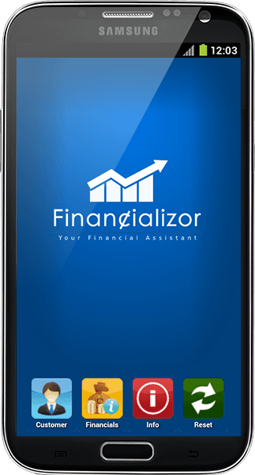

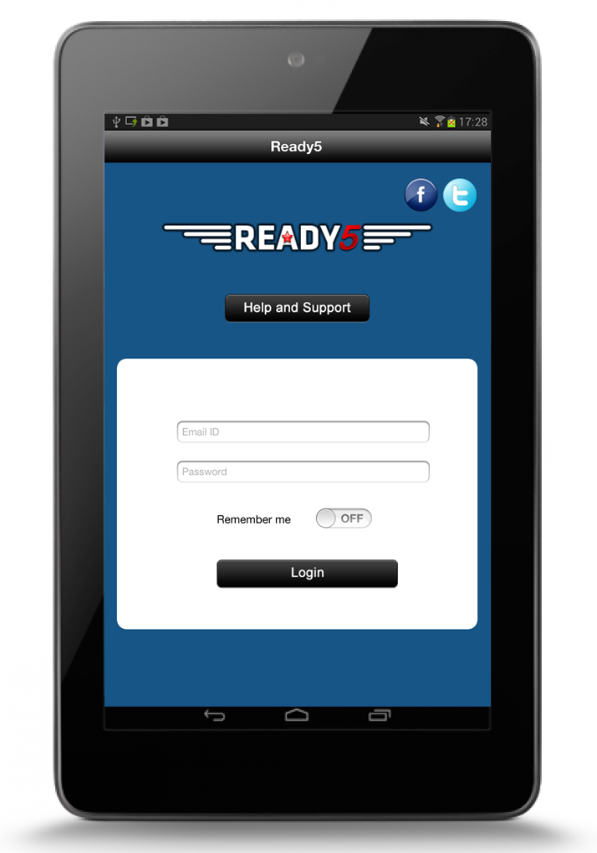

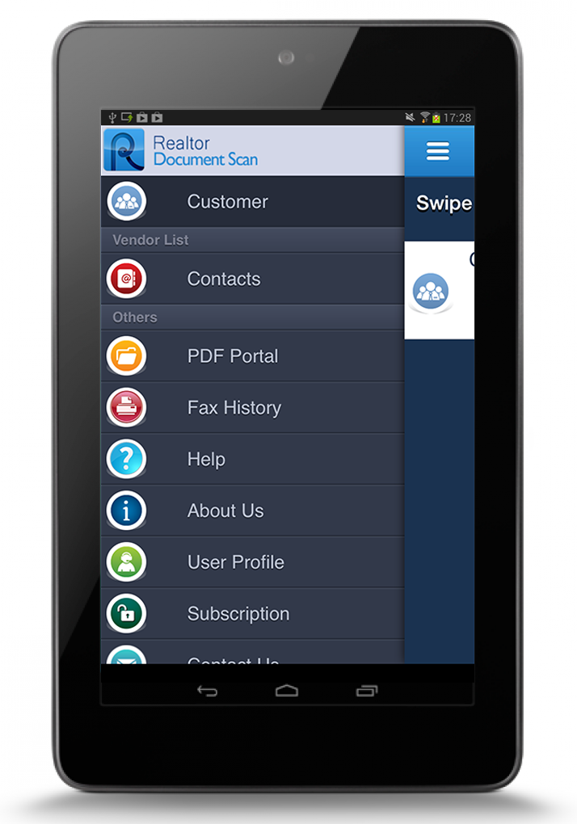

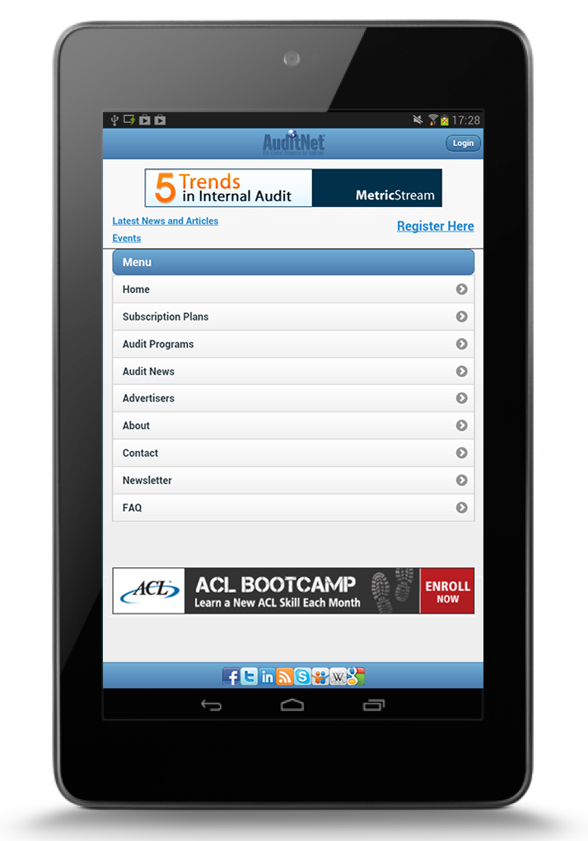

# Benefits of Hiring Us

1. More than 30 skilled and experienced iOS developer
2. Proper requirement analysis and documentation
3. Research on the similar kind of app
4. Regular scrums & updates
5. Free project collaboration tool access
6. Milestone wise delivery & payment
7. App store deployment help & support
8. Free Post release support of the app for one month

# Why iOS app?

During our research we found the iOS app market is incredibly lucrative, but in order to be successful, you have to have the right app, the right functionality, the right rollout and the right support. The CRM industry is growing and having presence in iOS platform will boost the customer engagement. The iOS app presence will definitely create a direct marketing channel, also build Brand & Recognition.

CRM mobile app will allow sales team's access to customer data through a mobile app. The key benefit is to allow your sales force to access real time data while out in the fields meeting prospects and customers.

During our initial research we found the iOS user base is larger than Android in US market. So we suggest for a native iOS app development which will add a value to the SaaS version of the CRM app.

# Project scope

The specifications listed below outline the scope of work to be completed for the Mobile application. The mobile application will be developed in ***native platform*** *for* iOS. The Webservice API will be placed in the existing web application developed using ***Ruby on Rails*** technology.

Crm-4Beauty is already having its own web application i.e running for its own practice. Keeping in mind the growth of CRM industry, CRM-4Beauty wanted to build another platform using their own piece of code of the existing web application. Andolasoft helped CRM-4beauty to setup the new multi-tenant SAAS based web application i.e currently running in heroku platform(<http://theconversiondoctor.herokuapp.com>).

Due to the growth of iOS application usages, there is an opportunity for CRM-4Beauty to attract iOS users looking for Customer Relationship Management. As the smartphone application would help the users to seamlessly access the core functionalities like statistics, lead management, task management...etc.

# Deliverables & Releases

* Push notification settings
* Splash screen
* Login page
* Dashboard page
* Leads list
* Lead detail page
* Lead edit page
* Push notification on Lead assignment
* Task list page
* Task detail page
* Task edit page
* Push notification on task assignment
* Task delete
* Task event entry on the device calendar
* App notification on the due date for upcoming task

**Release#1**

* Splash Screen
* Authentication
* Dashboard

**Release#2**

* Leads list
* Lead detail page
* Lead edit page
* Push notification on Lead assignment

**Release#3**

* Task list page
* Task detail page
* Task edit page
* Push notification on task assignment
* Task delete
* Task event entry on the device calendar

# Sample App Screenshots

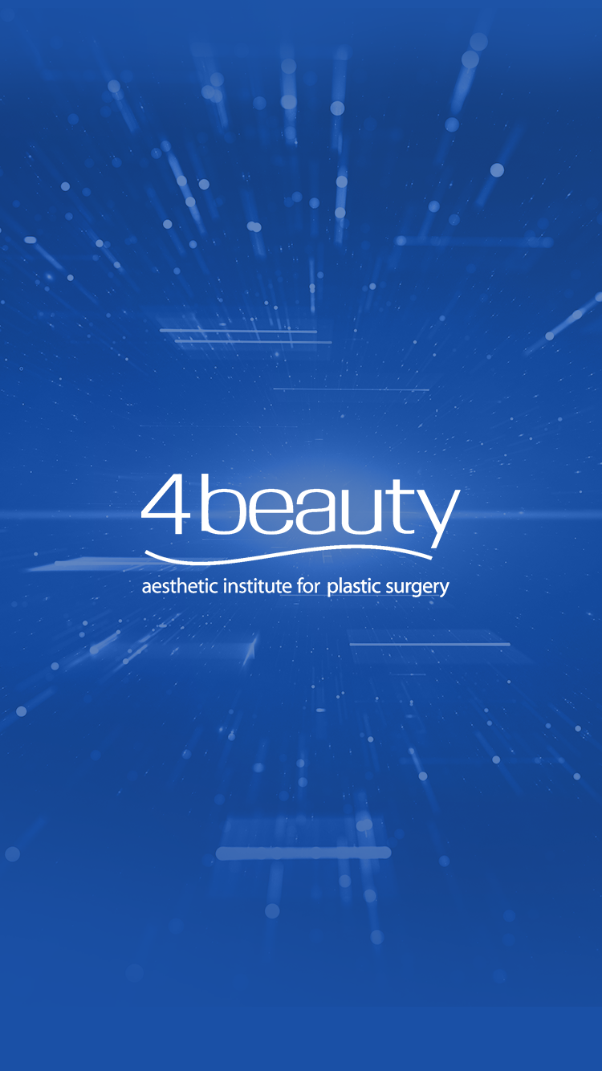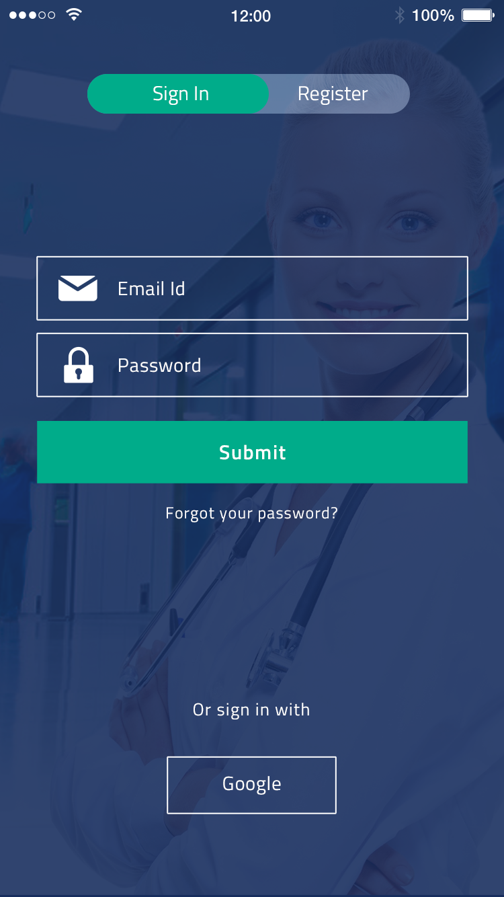

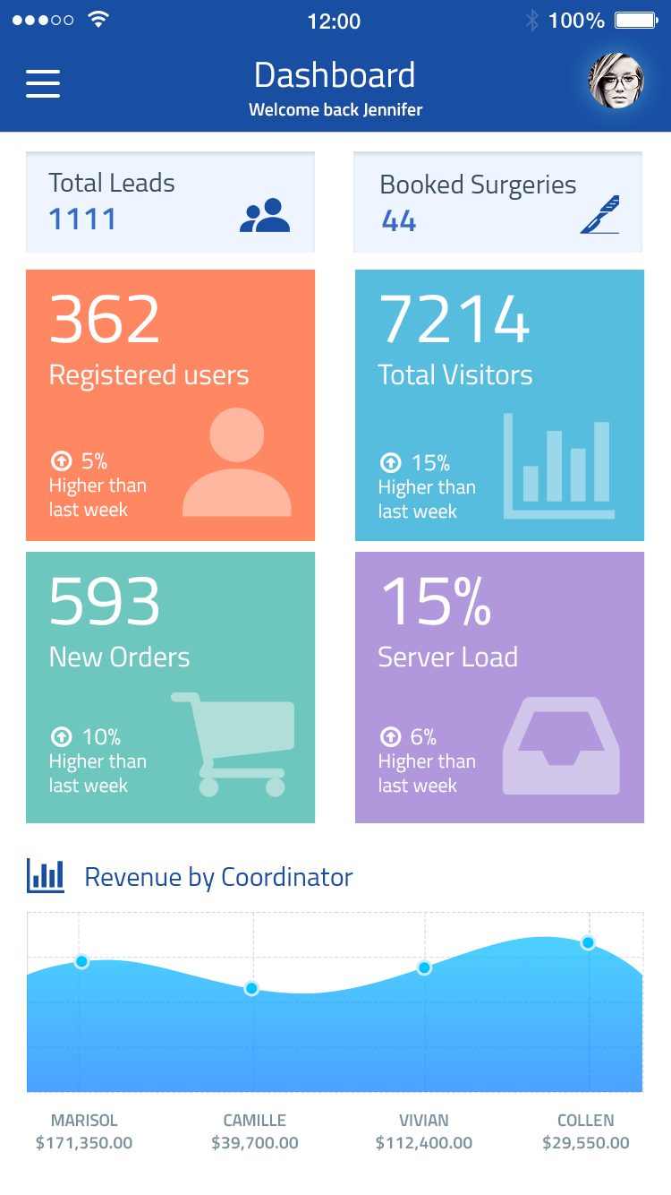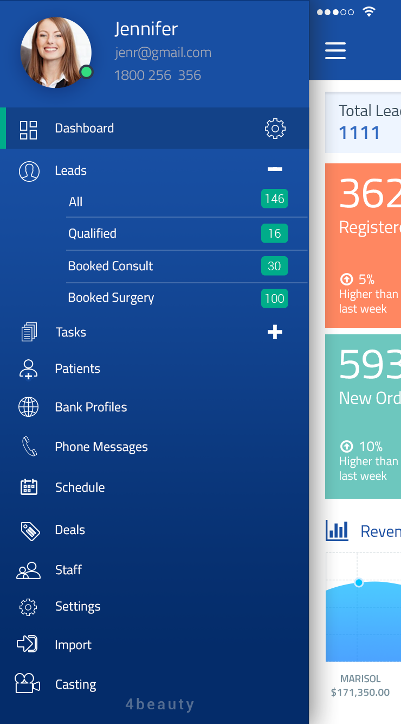

# Team structure

* Project Manager – 1
* Sr. developer - 2
* QA - 1

# Project Timeline& Cost Estimation

To complete the mobile application development would take approximately **4weeks** of time. The pricing for the development varies depending upon the technology used to develop the mobile application as listed below

|  |  |  |  |
| --- | --- | --- | --- |
| **Item** | **Pricing/Hour** | Engagement time  (**Man Hours**) | **Total** |
| iOS development | $25 | 160 | $4,000 |
| API development | $25 | 60 | $1,500 |
|  | **Grand Total** | | **$5,500** |

# Payment Method and Phases

|  |  |  |
| --- | --- | --- |
| Payment Milestones | % | Amount in **USD** |
| Advance on signing up the contract | 30% | $1,650 |
| On completion of the Release#1 demo | 30% | $1,650 |
| On completion of the Release#2 demo | 20% | $1,100 |
| On completion of the Release#3 demo | 20% | $1,100 |

* 30% of advance payment after signing of the contract. 30% of payment after 1st demo done for the release#1. 20% amount need to be released each time after the completion of Release#2 & Release#3 demo.
* All the payment shall be Wire Transfer to the bank details or through Credit Card sent through the invoice.
* The final instalment of the payment shall be released after completion of the mobile app development and before code handover/submitted to respective app stores

# Support & maintenance plan for mobile app (Optional)

Andolasoft would like to propose for the support and maintenance plan for the developed smartphone application. Following items are covered during the support & maintenance plan.

* Responding to customer queries
* Providing Operating Systems related enhancements
* Ensuring functionality updates
* Support for New Devices
* Support for New OS
* Analytics and monthly Reporting

**Note**–The following pricings are not included on the Pricing section mentioned at Cost estimation.

The monthly retainer fee for the support & maintenance plan is ***$599 per month***. There will be free support provided for ***8 hours each month*** during the support & maintenance plan.

The hourly charges after free service is ***$25/hour***

# Change Request Process

Our technical team will analyse every change requests received from client. If the change requires significant time and effort, the same will be notified to client and appropriate effort and schedule slippage will be notified to client for approval.

# Terms & Conditions

* FREE support of 30 days would be provided by Andolasoft for any issues/defects/ to ONLY the features to be delivered as per the specification discussed in Milestone. All the cases will be created in OrangeScrum, technical team member will respond to it.
* Andolasoft would provide free support in order to publish the apps in beta/production version to the respective app stores – iOS & Android
* In order to publish the apps in respective app stores,**4beauty** needs to provide respective App store credentials to Andolasoft.
* AndolaSoft would provide free support & service if any issue found during the app publishing process to iTunes& Android play store.
* However, any work unrelated to the scope originally disclosedby**4beauty**is chargeable as hourly basis. Rate will be **$25/Hour.**
* It is the sole responsibility of **4beauty**to provide legal graphical properties (free from copyright)
* Otherwise, **4beauty**can authorise Andolasoft to buy images on their behalf
* Any relevant database or API to be provided by**4beauty**on the beginning of the project.
* Feedback loop has to be closed by the **4beauty**within 24 hours in-case of weekdays & 48 hours in-case of weekends during development.

IN WITNESS WHEREOF, the parties have executed this Agreement as of the Effective Date.

**For and on behalf of Andolasoft Inc: For and on behalf of 4Beauty**:

By: _____________________ By: _______________________

Print Name: Priyabrata Gharai Print Name: Max Rockwell

As Its: CEO As Its: Marketing Director